Fédération de Recherche ECCOREV n° 3098

CNRS/Aix Marseille Université

Europôle Méditerranéen de l’Arbois

Bâtiment Laennec

13545 Aix en Provence cedex 4

Direction : Nicolas Roche

Nicolas.roche@univ-amu.fr

Administration : Joëlle Cavalieri

Tél : 06 66 03 84 72

[Joelle.cavalieri@univ-amu.fr](mailto:Joelle.cavalieri@univ-amu.fr)

Site internet : <http://www.eccorev.fr/>

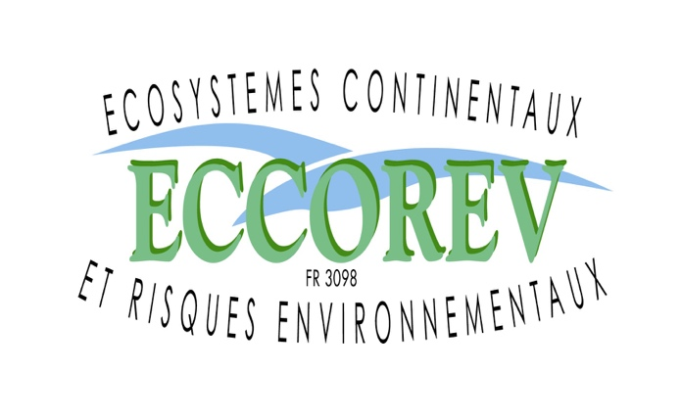

**Journée Restitution de l’Appel d’Offre Interne 2021**

**Mercredi 23 octobre 2024**

**Aix en Provence Technopole de l’Arbois**

**Fiche-Résumé**

**Titre : Mécanismes bio-physico-chimiques d’interaction au sein de cOcktails de polluants émeRgents dans les écOsystèmes aquatiques : MORITO**

**Porteur du projet : Melanie Auffan, Lenka Brousset**

**Participants :** Danielle Slomberg, Jeanne Perrin, Alain Thiery

**Laboratoires et Partenaires impliqués :** CEREGE, IMBE

**Principaux résultats :** The emergence of new technologies represents an environmental challenge while assessing the environmental risks of innovative materials and emerging pollutants. Among these contaminants, we find products of industrial origin (engineered nanomaterials ENMs, critical metals), human or veterinary drugs, products of daily use, *etc*. To date, there is an extensive literature on identifying the mechanisms of toxicity and ecosystem exposure to individual emerging pollutants. However, organisms are more prone to be concomitantly exposed to wide-ranging cocktails of emerging pollutants rather than individual ones. The large specific surface area and important surface energy of ENMs play a significant role in these ‘cocktail effect’. The ENMs surface is the place where chemical exchanges (anions, cations) and electrochemical exchanges (electrons, protons) take place, not to mention adsorption/desorption reactions, all of which involving species in solution as pollutant cations or biological molecules.

This project focused on characterizing the exposure of an ecosystem to a mixture of ENMs at relevant lifecycle stages (production, and end of life) and assessing the main mechanisms driving their fate and behavior (as aggregation, dissolution, ROS generation). Two relevant sources of ENMs were selected: an industrial TiO2 ENMs likely released close to manufacturing sites (called indus-TiO2 ENMs) (Slomberg et al. 2020) and combusted CeO2 ENMs-based diesel additives likely release in diesel exhausts (called CeO2 ENMs) (Auffan et al. 2017). By combining freshwater mesocosm experiment with mechanistic experiments in batch, we carefully studied whether the co-contamination of an ecosystem to the pro-oxidant TiO2 ENMs and the anti-oxidant CeO2 ENMs will have synergistic or antagonistic impacts in term of reactive oxygen species generation and aggregation states.

We observed that the metal partitioning following ENMs mix contamination was driven by the strong chemical stability and fast homo-aggregation of comb-CeO2 and indus-TiO2. They will both settling down at the surface of the sediment where they significantly contaminate the ecological niche of the adult benthic grazers *P. corneus*. No antagonistic effect was observed in term of reactive oxygen species production. While at this stage it is difficult to conclude about the effect on the organisms, we do note that a more important remobilization of the sediments and resuspension of suspended particles by benthic grazers in the non-contaminated mesocosms. This could indicate a lower biological activity in ENMs mix-contaminated mesocosms, although no significant mortality has been observed after the 28 days contamination.

**Publications, congrès :** Co-exposure of a pond ecosystem to a mixture of metal-based nanomaterials. Amazigh Ouaksel1, Martina Cotena1,2, Danielle Slomberg1, Lenka Brousset 2, Bernard Angeletti1, Alain Thiéry 2, Vladimir Vidal1, Corinne Chanéac3, Jeanne Perrin2, Jerome Rose 1,4, Melanie Auffan 1,4 *1 CEREGE, CNRS, Aix Marseille Univ, IRD, INRAE, Aix-en-Provence, France, 2 CNRS, Aix-Marseille Université, CNRS, IMBE, UMR 7263, Marseille, France, 3 Sorbonne Université, CNRS, Laboratoire de Chimie de la Matière Condensée de Paris, UMR 7574, F-75005 Paris, France, 4 Civil and Environmental Engineering, Duke University, Durham, NC, United States*

**Suite donnée au projet (**contrats nationaux, internationaux, bourses de thèse…):