Fédération de Recherche ECCOREV n° 3098

CNRS/Aix Marseille Université

Europôle Méditerranéen de l’Arbois

Bâtiment Laennec

13545 Aix en Provence cedex 4

Direction : Nicolas Roche

Nicolas.roche@univ-amu.fr

Administration : Joëlle Cavalieri

Tél : 06 66 03 84 72

[Joelle.cavalieri@univ-amu.fr](mailto:Joelle.cavalieri@univ-amu.fr)

Site internet : <http://www.eccorev.fr/>

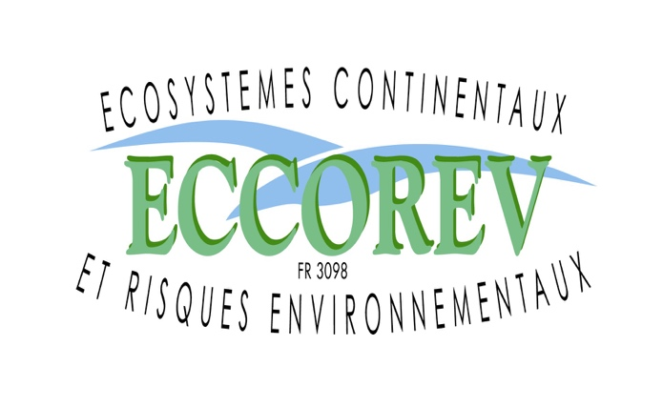

**Journée Restitution de l’Appel d’Offre Interne 2021**

**Mercredi 23 octobre 2024**

**Aix en Provence Technopole de l’Arbois**

**Fiche-Résumé**

**Titre : Grands cratères d’impact météoritique au Pléistocène en zone tropicale : perturbation et résilience de l’écosystème forestier**

**Porteur du projet : P. Rochette**

**Participants :** V. Andrieu

**Laboratoires et Partenaires impliqués :** CEREGE, IMBE

**Principaux résultats :**

Résumé de l’article en préparation :

**Global environmental effects of major hypervelocity impacts, such as the 180 km diameter Chixulub crater [1-3], have been used 40 years ago to predict the consequences of a future global nuclear war. Smaller impacts, with craters of 10 km diameter and over, may generate severe regional damages over a 100-150 km radius including forest destruction through fire and airblast [4]. As such, they may provide past examples to better evaluate consequences of megafires occurring now or predicted in our near future [5,6]. 1.07 Myr ago an asteroid stroke the pluvial forest of southern Ghana in Bosumtwi, generating a 10.5 km diameter crater and a distal ejecta of glass droplets in the form of tektites and microtektites [7,8]. Here we show, by studying a deep-sea core 350 km away from the impact, that the microtektite layer is accompanied by a prominent peak in charcoal, uncharred wood and fungi associated with dead wood. Pollen assemblage points toward temporal increase in opportunist plants before recovery of the forest. This indicates that forest was destroyed over a surface around the impact significant enough to produce a signal in the core that reflects an extended regional megafire signal over West Africa.**

References:

1 Alvarez, L.W., Alvarez, W., Asaro, F., and Michel, H.V. (1980) Extraterrestrial cause for the Cretaceous-Tertiary extinction. Science 208, 1095–1108.

2 Wolbach, W.S., Lewis, R.S., and Anders,E. (1985) Cretaceous extinctions: evidence for wildﬁres and search for meteoritic material. Science 230,167–170. <https://science.sciencemag.org/content/230/4722/167>

3. Toon O. et al. 1997. Environmental perturbations caused by the impacts of asteroids and comets. Reviews of Geophysics 35: 41–78. <https://doi.org/10.1029/96RG03038>

4. Collins et al. 2005. Earth Impact Effects Program: A Web-based computer program for calculating the regional environmental consequences of a meteoroid impact on Earth. Met. Planet. Sc. 40, 817–840. https://impact.ese.ic.ac.uk/ImpactEarth/ <https://doi.org/10.1111/j.1945-5100.2005.tb00157.x>

5 Johnston et al., 2021. Unprecedented health costs of smoke-related PM(2.5) from the 2019-20 Australian megafires. Nature Sustainability 4, <https://doi.org/10.1038/s41893-020-00610-5>

6 William J. de Groot, Michael D. Flannigan, Alan S. Cantin 2013 Climate change impacts on future boreal fire regimes, Forest Ecology and Management, 294, 35-44 <https://doi.org/10.1016/j.foreco.2012.09.027>

7. Glass et al. 1991. Ivory-coast microtektite strewn field - description and relation to the Jaramillo geomagnetic event. EPSL: 107, 182-196. <https://doi.org/10.1016/0012-821X(91)90054-L>

8 Koeberl C., Reimold W. U., Blum J. D., and Chamberlain C. P. (1998) Petrology and Geochemistry of Target Rocks from the Bosumtwi Impact Structure, Ghana, and Comparison with Ivory Coast Tektites. *Geochimica et Cosmochimica Acta* 62, 2179–96.

**Publications, congrès :**

**Présentation au congrès de l’INQUA Rome (2023) : First evidence for a major environmental crisis triggered by the Bosumtwi impact event (1.07 Ma) in the west African forest**

Nguyen Van Binh, **Andrieu** Valérie, **Rochette** Pierre, et al.

Article en cours de préparation avec le même titre.

Autre article connexe : Soro P., **Rochette** P., Baratoux D., Kouamelan A.N., **Andrieu** V., Monda O., 2023. Revisiting the Côte d’Ivoire tektite strewn field. Journal of African Earth Sciences 205, 104990. DOI: [10.1016/j.jafrearsci.2023.104990](http://dx.doi.org/10.1016/j.jafrearsci.2023.104990" \t "_blank)

**Suite donnée au projet (**contrats nationaux, internationaux, bourses de thèse…):

Obtention d’une ANR 2022-2025 :

https://www.cerege.fr/fr/sciences/terre-et-planetes/projets-terre-et-planete/anr-et-megafire/

Thèse en cours de finition de V. Nguyen.